Ayush Goyal
190905522 CSE D Roll 62

Compiler Design Lab 6(Week 5): Recursive Descent Parser

Write a recursive descent parser for the following simple grammars:

1. S -> a | > | ( T )
T -> T, S|S

Code:

#include<stdio.h>
#include<stdlib.h>
#include<string.h>

int curr = 0;
char str[100];
void S();
void T();
void tPrime();

void printValid(){
printf("\n *** Sucessful! ***\n");
exit(0);
}

void printInvalid(){
printf("\n *** Unsucessful! ***\n");
exit(0);
}

void S(){
if(str[curr] == 'a' || str[curr] == '>'){
curr++;
return;
}
else if(str[curr] == '('){
curr++;
T();
if(str[curr] == ')'){
curr++;
return;
}
else
printInvalid();
}
else
printInvalid();
}

void T(){
S();
tPrime();
}

void tPrime(){
if(str[curr] == ','){
curr++;
S();
tPrime();
}
}

void main(){
printf("Enter the String: \n");
scanf("%s",str);
S();
if(str[curr] == '$')
printValid();
else
printInvalid();
}

Output:

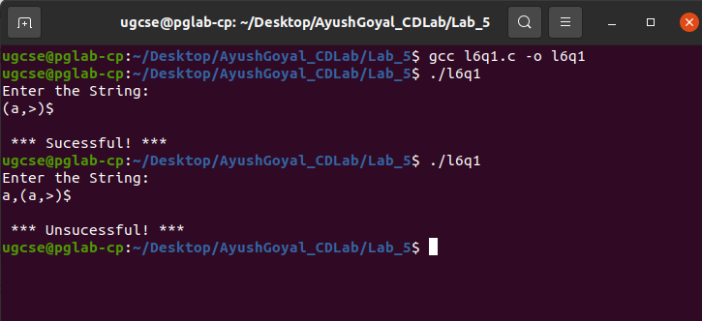

2. S -> UVW
U -> (S) | aSb | d
V -> aV | ε
W -> cW | ε

Code:

#include<stdio.h>
#include<stdlib.h>
#include<string.h>

int curr = 0;
char str[100];
void S();
void U();
void V();
void W();

void printValid(){
printf("\n *** Sucessful! ***\n");
exit(0);
}

void printInvalid(){
printf("\n *** Unsucessful! ***\n");
exit(0);
}

void S(){
U();
V();
W();
}

void U(){
if(str[curr] == '('){
curr++;
S();
if(str[curr] == ')'){
curr++;
return;
}
else
printInvalid();
}
else if(str[curr] == 'a'){
curr++;
S();
if(str[curr] == 'b'){
curr++;
return;
}
else
printInvalid();
}
else if(str[curr] == 'd'){
curr++;
return;
}
else
printInvalid();
}

void V(){
if(str[curr] == 'a'){
curr++;
V();
}
}

void W(){
if(str[curr] == 'c'){
curr++;
W();
}
}

void main(){
printf("Enter the String: \n");
scanf("%s",str);
S();
if(str[curr] == '$')
printValid();
else
printInvalid();
}

Output:

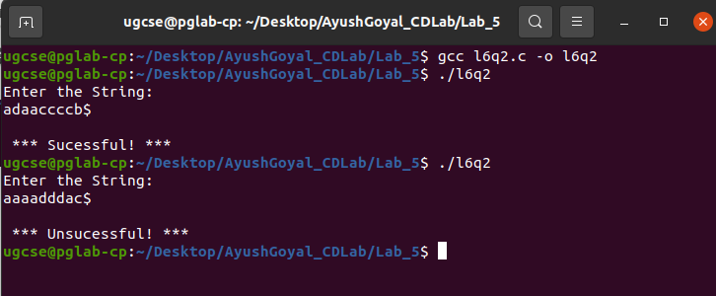

3. S -> aAcBe
A -> Ab|b
B -> d

Code:

#include<stdio.h>
#include<stdlib.h>
#include<string.h>

int curr = 0;
char str[100];
void S();
void A();
void B();
void aPrime();

void printValid(){
printf("\n *** Sucessful! ***\n");
exit(0);
}

void printInvalid(){
printf("\n *** Unsucessful! ***\n");
exit(0);
}

void S(){
if(str[curr] == 'a'){
curr++;
A();
if(str[curr] == 'c'){
curr++;
B();
if(str[curr] == 'e'){
curr++;
return;
}
else
printInvalid();
}
else
printInvalid();
}
else
printInvalid();
}

void A(){
if(str[curr] == 'b'){
curr++;
aPrime();
}
else
printInvalid();
}

void aPrime(){
if(str[curr] == 'b'){
curr++;
aPrime();
}
}

void B(){
if(str[curr] == 'd'){
curr++;
return;
}
else
printInvalid();
}

void main(){
printf("Enter the String: \n");
scanf("%s",str);
S();
if(str[curr] == '$')
printValid();
else
printInvalid();
}

Output:

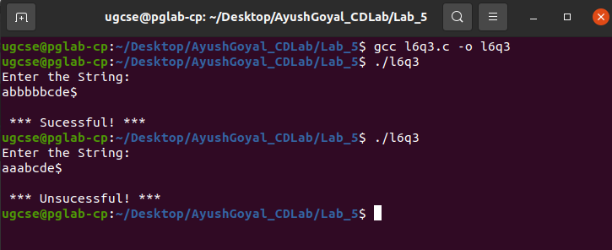

4. S -> (L) | a
L -> L,S | S

Code:

#include<stdio.h>
#include<stdlib.h>
#include<string.h>

int curr = 0;
char str[100];
void S();
void L();
void lPrime();

void printValid(){
printf("\n *** Sucessful! ***\n");
exit(0);
}

void printInvalid(){
printf("\n *** Unsucessful! ***\n");
exit(0);
}

void S(){
if(str[curr] == 'a'){
curr++;
return;
}
else if(str[curr] == '('){
curr++;
L();
if(str[curr] == ')'){
curr++;
return;
}
else
printInvalid();
}
else
printInvalid();
}

void L(){
S();
lPrime();
}

void lPrime(){
if(str[curr] == ','){
curr++;
S();
lPrime();
}
}

void main(){
printf("Enter the String: \n");
scanf("%s",str);
S();
if(str[curr] == '$')
printValid();
else
printInvalid();
}

Output:

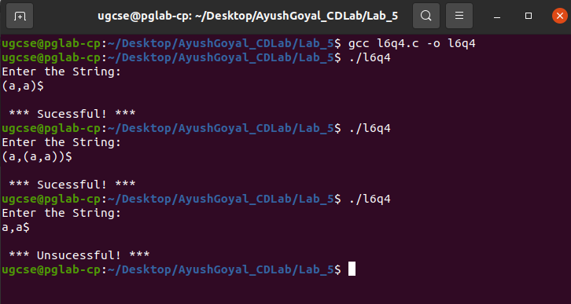

THE END

